**Level 1: PC Tower Case**

**Outline**

Learn about the internals of a standard PC case by examining physical samples and selecting and labeling images found on-line. Gain deeper knowledge by researching and reporting on specific components.

**Questions**

1. Find one (or more) images that clearly show the internals of a PC Tower Case.   
   (i.e. Google images using keywords “PC Case Internals”)

**On github repository**

1. Clearly label the following components (using arrows) on your image of the PC case internals:
   * Motherboard
   * Power Supply
   * Hard Disk Drive
   * Optical Disk Drive (e.g.DVD)
   * USB Expansion Ports
   * Monitor Port
   * Audio Ports
   * Ethernet Port
   * Cooling Fan

**On Github Repository separate PowerPoint**

1. Research more in-depth about “Motherboards”. Make notes on the following:

What different versions are currently available (speed and capacity)

* **Motherboards offer more R.A.M slots (up to 8)**
* **Bigger motherboards**
* **Have more slots**

How the component has changed since the 1980’s

* **Ram slots back then only were offered in only MB now they have GB**
* **Have a separate slot for a graphics card for better graphics**

1. Research more in-depth about “Hard Disk Drives”. Make notes on the following:

What different versions are currently available (speed and capacity)

* + **Up to 8 Terabytes in hard drives**

How the component has changed since the 1980’s

* + **Back then hard drives were only available in Gb’s**

**Level 2: PC Motherboard**

**Outline**

Learn about the structure of a standard PC motherboard by examining physical samples and selecting and labeling images found on-line. Gain deeper knowledge by researching and reporting on specific components.

**Questions**

1. Find one (or more) images that clearly show the layout of a PC Motherboard.   
   (i.e. Google images using keywords “PC Motherboard”)

**On separate PowerPoint on repository**

1. Clearly label the following components (using arrows) on your image of the PC motherboard:
   * CPU (and fan)
   * RAM Memory
   * Disk Drive Interface (IDE or SATA)
   * GPU Graphics Processor (either on-board or Graphics Card)
   * Sound Processor (either on-board or Sound Card)
   * Wi-Fi / Ethernet Network Interface (either on-board or Graphics Card)

**On github repository**

1. Research more in-depth about “CPU Processor Chip”. Make notes on the following:

What different versions are currently available (speed and capacity)

* + **Faster**
  + **Can address more memory**
  + **64-bit**

How the component has changed since the 1980’s

* **8-bit CPUs**
* **Slow**
* **Low amount of slots for Graphics cards/PCI’s/RAM slots**

1. Research more in-depth about “RAM Memory”. Make notes on the following:
   * What different versions are currently available (speed and capacity)
   * **DDR3 and DDR4 RAM sticks are much faster**
   * **Can have up to 128GB of R.A.M**
   * How the component has changed since the 1980’s
   * **R.A.M was in MB**
   * **Low amount of R.A.M**

**Level 3: Peripheral Devices**

**Outline**

Learn about how peripheral devices are connected to the back side of a typical PC tower case. Examine physical samples, select and labeling images found on-line and gain deeper knowledge by researching and reporting on specific components.

**Questions**

1. Find one (or more) images that clearly show the layout of the back of a typical PC tower case.   
   (i.e. Google images using keywords “Back Of PC Tower”)

**On separate PowerPoint**

1. Clearly label the following components (using arrows) on your image of the back of a typical PC tower case:
   1. Power cord and power switch
   2. Monitor Interface (VGA or DVI or HDMI)
   3. Mouse Interface (USB or PS/2)
   4. Keyboard Interface (USB or PS/2)
   5. USB Ports
   6. Audio Inputs / Outputs
   7. Ethernet Interface

**ON github reposirtory**

1. Research more in-depth about “Monitor Technology”. Make notes on the following:
   1. What different versions are currently available (e.g. VGA / DVI, Flat Panel Technology)

**Panel technologies. The overwhelming majority of computer monitors, laptop screens and tablets are based on TFT-LCD**

* 1. How the component has changed since the 1980’s (e.g. Display Resolution, Technology)

**Electrically operated display devices have developed from electromechanical systems for display of text, up to all-electronic devices capable of full-motion 3D color graphic displays. One of the earliest electronic displays is the cathode ray tube (CRT), which was first demonstrated in 1897 and made commercial in 1922.**

1. Research more in-depth about “External Portable Storage”. Make notes on the following:
   1. Floppy Disks

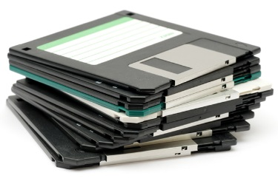

* **is a type of disk storage composed of a disk of thin and flexible magnetic storage medium, sealed in a rectangular plastic enclosure lined with fabric that removes dust particles. Floppy disks are read and written by a floppy disk drive.**
  1. CD-ROM / DVD / Recordable CD/DVD

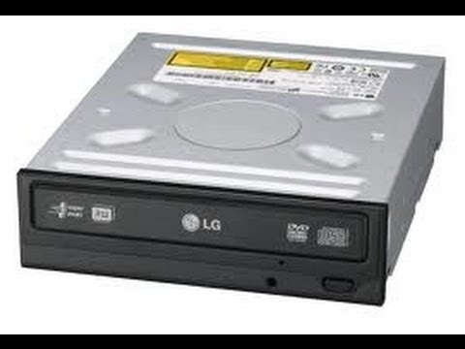

* **CD-ROM: a compact disc used as a read-only optical memory device for a computer system.**
* **DVD: is a digital optical disc storage format invented and developed in 1995. The medium can store any kind of digital data and is widely used for software and other computer files as well as video programs watched using DVD players**
* **Recordable CD/DVD: is a digital optical disc storage format. A CD-R disc is a compact disc that can be written once and read arbitrarily many times.CD-R discs (CD-Rs) are readable by most plain CD readers**,
  1. USB Memory Drives

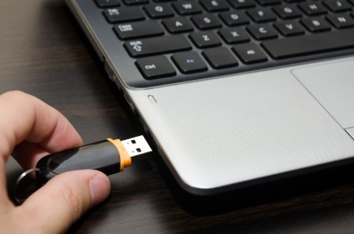

* **A USB flash drive is a device used for data storage that includes a flash memory and an integrated Universal Serial Bus (USB) interface. Most USB flash drives are removable and rewritable. Physically, they are small, durable and reliable. The larger their storage space, the faster they tend to operate.**
  1. Compact Flash Memory

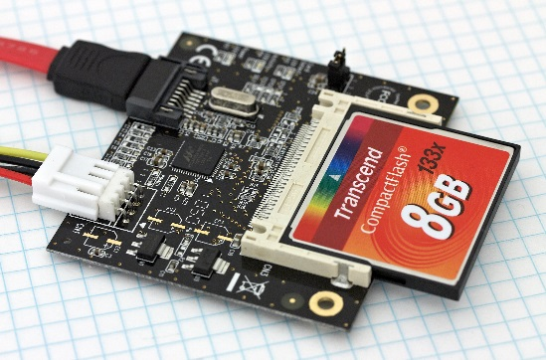

* **is a flash memory mass storage device used mainly in portable electronic devices. The format was specified and the devices were first manufactured by SanDisk in 1994. CompactFlash became the most successful of the early memory card formats, surpassing Miniature Card and SmartMedia.**
  1. Cloud Based Storage  
     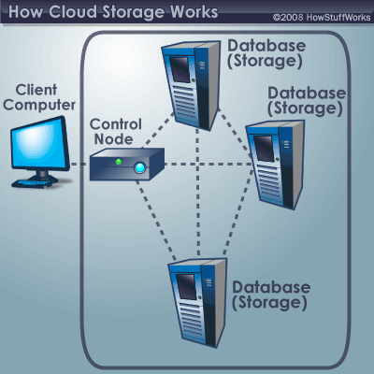
* Cloud Based Storage**: is a cloud computing model in which data is stored on remote servers accessed from the internet, or "cloud." It is maintained, operated and managed by a cloud storage service provider on a storage servers that are built on virtualization techniques.**